Chapter 16, Solution 89.

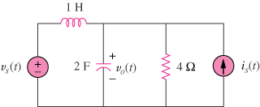

First select the inductor current i_{L} (left to right) and the capacitor voltage v_{C} to be the state variables.

Letting v_{o} = v_{C} and applying KCL we get:

Thus,

